WEEK 3
TASK 3.1 : JAVA DATE AND TIME
PROGRAM:
class Result {

public static String findDay(int month, int day, int year) {
java.util.Calendar cal = java.util.Calendar.getInstance
cal.set(year, month - 1,day);
return cal.getDisplayName(
java.util.Calendar.DAY_OF_WEEK,
java.util.Calendar.LONG,
Locale.ENGLISH
).toUpperCase();

}

}
OUTPUT:
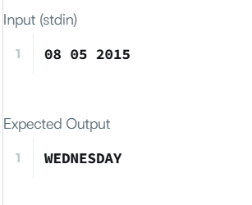

TASK 3.2: NUMBER OF DAYS BETWEEN TWO DAYS
PROGRAM:
import java.time.LocalDate;
import java.time.temporal.ChronoUnit;

class Solution {
public int daysBetweenDates(String date1, String date2) {

LocalDate d1 = LocalDate.parse(date1);
LocalDate d2 = LocalDate.parse(date2);
return (int) Math. Abs(ChronoUnit.DAYS.between(d1,d2));
}
}

OUTPUT:
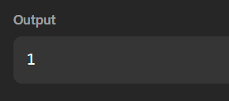

TASK 3.3:DAY OF THE YEAR
PROGRAM:
import java.time.LocalDate;

class Solution {
public int dayOfYear(String date) {

LocalDate d = LocalDate.parse(date);

return d.getDayOfYear();

}
}

OUTPUT:
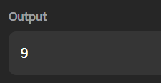

TASK 3.4: DAY OF THE WEEK
PROGRAM:
import java.time.LocalDate;
import java.time.format.TextStyle;
import java.util.Locale;

class Solution {
public String dayOfTheWeek(int day, int month, int year) {

LocalDate date = LocalDate.of(year,month, day);

return date.getDayOfWeek()
.getDisplayName(TextStyle.FULL, Locale.ENGLISH);
}
}
OUTPUT:
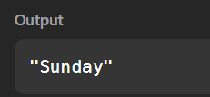

TASK 3.5: JAVA PRIORITY QUEUE
PROGRAM:
import java.util.*;
class Student {
private int id;
private String name;
private double cgpa;
public Student(int id, String name, double cgpa) {
this.id = id;
this.name = name;
this.cgpa = cgpa;
}
public int getID() {
return id;
}
public String getName() {
return name;
}
public double getCGPA() {
return cgpa;
}
}
class Priorities {
public List<Student> getStudents(List<String> events) {
PriorityQueue<Student> pq = new PriorityQueue<>(
(s1, s2) ->
if (s1.getCGPA() != s2.getCGPA()) {
return Double.compare(
s2.getCGPA(),
s1.getCGPA()
);
}
int nameCompare =
s1. getName().compareTo(s2.getName());
if (nameCompare != 0) {
return nameCompare;
}
return Integer.compare(
s1.getID(),
s2.getID()
);
}
);
for (String event : events) {
if (event.startsWith("ENTER")) {
String[] parts = event.split(" ");
String name = parts[1];
double cgpa = Double.parseDouble(parts[2]);
int id = Integer.parseInt(parts[3]);
pq.add(new Student(id, name, cgpa));
} else if (event.equals("SERVED")) {
if (!pq.isEmpty()) {
pq.poll();
}
}
}
List<Student> result = new ArrayList<>();
while (!pq.isEmpty()) {
result.add(pq.poll());
}
return result;
}
}
public class Solution {
public static void main(String[] args) {
Scanner sc = new Scanner(System.in);
int n = sc.nextInt();
sc.nextLine();
List<String> events = new ArrayList<>();
for (int i = 0; i < n; i++) {
events.add(sc.nextLine());
}
Priorities priorities = new Priorities();
List<Student> students =
priorities.getStudents(events);
if (students.isEmpty()) {
System.out.println("EMPTY");
} else {
for (Student student : students) {
System.out.println(student.getName());
}
}

sc.close();
}
}

OUTPUT:
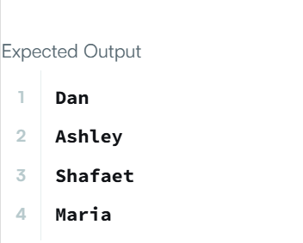

TASK 3.6:JAVA ARRAYLIST
Program:
import java.io.*;
import java.util.*;
public class Solution {
public static void main(String[] args) {
Scanner sc = new Scanner(System.in);
int n = sc.nextInt();
ArrayList<ArrayList<Integer>> list = new ArrayList<>();
for (int i = 0; i < n; i++) {
int d = sc.nextInt();
ArrayList<Integer> numbers = new ArrayList<>();
for (int j = 0; j < d; j++) {
numbers.add(sc.nextInt());
}
list.add(numbers);
}

int q = sc.nextInt();
for (int i = 0; i < q; i++) {
int x = sc.nextInt();
int y = sc.nextInt();
try {
System.out.println(list.get(x - 1).get(y - 1));
}
catch (IndexOutOfBoundsException e) {
System.out.println("ERROR!");
}
}

sc.close();
}
}
OUTPUT:
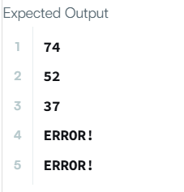

TASK 3.7:LARGEST NUMBER
PROGRAM:
class Solution {
public String largestNumber(int[] nums) {
String[] arr= new String[nums.length];
for (int i = 0;i < nums.length; i++) {
arr[i] = nums[i] + "";
}
Arrays.sort(arr, (a,b) -> (b + a).compareTo(a+b));
if (arr[0].equals("0")) {
return "0";
}
String answer = "";
for (String s: arr) {
answer = answer + s;
}
return answer;

}
}
OUTPUT:
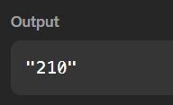

TASK 3.8:JAVA COMPARATOR
PROGRAM:
import java.util.*;
class Checker implements Comparator<Player> {
public int compare(Player a, Player b) {
if (a.score != b.score) {
return b.score - a.score;
}
return a.name.compareTo(b.name);
}
}
class Player{
String name;
int score;
Player(String name, int score){
this.name = name;
this.score = score;
}
}
class Solution {
public static void main(String[] args) {
Scanner scan = new Scanner(System.in);
int n = scan.nextInt();
Player[] player = new Player[n];
Checker checker = new Checker();
for(int i = 0; i < n; i++){
player[i] = new Player(scan.next(), scan.nextInt());
}
scan.close();

Arrays.sort(player, checker);
for(int i = 0; i < player. Length; i++){
System.out.printf("%s %s\n", player[i].name, player[i].score);
}
}
}
OUTPUT:
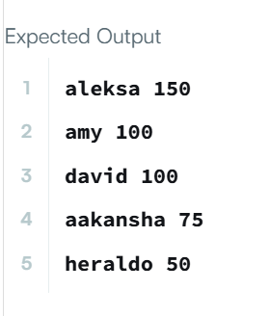

TASK 3.9:SORT THE PEOPLE
PROGRAM:
import java.util.*;
class Solution {
public String[] sortPeople(String[] names, int[] heights) {
Integer[] index = new Integer[names.length];
for (int i = 0; i < names.length; i++) {
index[i] = i;
}
Arrays.sort(index, (a, b) -> heights[b] - heights[a]);
String[] result = new String[names.length];
for (int i = 0; i < names.length; i++) {
result[i] = names[index[i]];
}
return result;
}
}
OUTPUT:
